**Probability**

The likelihood of an event occurring.

**Comparing:-** Winning Lottery compare to Flip Coins

**Definition:**

A – Event

P(A) – Probability

P(A) = Preferred/ All = (Favourable)/ (Sample Space)

**Coin Flip:**

A – Only Preferred outcome

P(A) = ½ = 0.5

**Six sided die:**

single preferred outcomes = 1

Total possible outcomes = 6

P(A) = 1/6 ~ 0.167

**Divisible by 3** : means either 3 or 6 so preferred outcomes = 2, total possible outcomes =6

P(A) = 3/6 = 0.5

**Winning the Lottery:**

Preferred outcomes = amount of tickets

Total possible outcomes = 175 millions

P(A) = 1/175 millions ~ 0.000 000 005

Flipping coin (0.5) probability is much higher than Winning the lottery.

**Expected Values:** the average outcome we expect if we run an experiment many times.

Trial 🡪 flip and record outcome

Experiment 🡪 multiple trials

Coin toss x 20 times and Record 20 outcomes 🡪 Single experiment with 20 trials

**Experimental probabilities:**

Experimental probabilities Vs Theoretical Probabilities (True)

Can’t be the same but A good experiment

P(A) = successful trials / all trials

**Expected Values:**

E(A) 🡪 the outcome we expect to occur when we run an experiment

**Categorical Outcomes**

Draw a spade if we draw cards 20 times. We return the card without shuffling the cards.

E(A) = P(A) * n = .25*20 = 5

**Numerical Outcomes**

Sample space (A,B,C)

A.P(A) + B.P(B) + C.P(C)

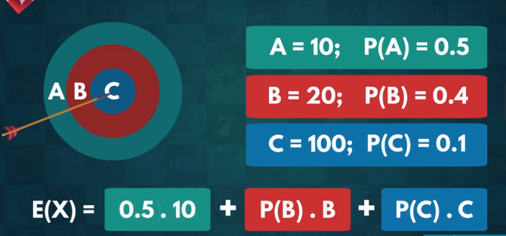

= 23

**We can use expected values to make predictions about the future based on past data.**

**Probability Distribution Theorem**

**Confusing E(A)**

A 🡪 Two dice in a single time

Favorable outcomes 🡪 6

Total possible outcomes 🡪 36

P(7) = 6/36 = 1/6

**E(A) = P(2)*2 + P(3)*3+ ………. + P(12)*P12 = 7**

**Importance of E(A):**

**P[E(A)] = P(7) = 1/6 🡪 most probable answer, still very unlikely**

**Probability Frequency Distribution:** a collection of the probabilities for each possible outcomes

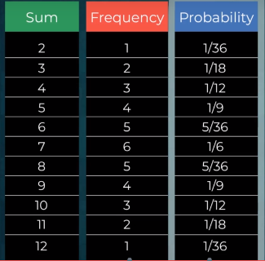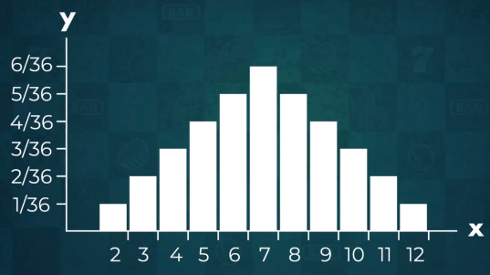

**Complements**

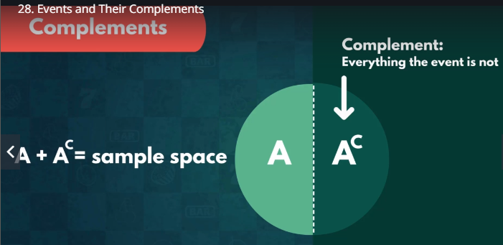

All Possible Outcomes 🡪 A, B and C

P(A) + P(B) = sum of probabilities of A & B

P(A) + P(B) + P(C) =1 🡨 100% certain

**P(A) + P(B) > 1 ?**

P(A) + P(B) = 1.5

* Absolute(1), Does not make intuitive sense, Double-counting

**P(A) + P(B) < 1 ?**

P<1, not guaranteed to occur

A’ 🡨 Complement

(A’)’ = A

A 🡪 Rolling an even number

A’ 🡪 Not Rolling an even number (rolling an odd number)

**Rolling a die:**

A🡪 Probability of getting 1, 2, 4, 5, 6

B 🡪 Probability of not getting 3

* A = B

All Possible Outcomes 🡪 A, B and C

P(A) + P(B) + P(C) =1

A’ = B + C

P(A’) = 1 – P(A)

Rolling a die:

P(A) – Probability of getting 1 or 2 or 4 or 5 or 6

P(A) = P(1) + P(2) + P(4) + P(5) + P(6)

= 1/6 + 1/6 + 1/6 + 1/6 + 1/6 = 5/6

B 🡪 Not 3, B’ 🡪 3, P(B’) = 1/6

P(B) = 1- P(B’) = 1 – 1/6 = 5/6

Probability of getting (1 or 2 or 4 or 5 or 6) = P(NOT 3)

P(A) = 5/6 = P(B)

**Combinatorics**

Deals with combination of objects for a specific finite set.

**Restrictions:**

* **Repetition**
* **Orders**
* **Other**
* **Permutations**
* **Variations**
* **Combinations**

**Number of favorable outcomes or Number of all elements in a sample space**

**Permutations**

The number of different possible ways we can arrange a set of elements. These elements can be digits, numbers, objects or even people.

Formula 1: How can top three medals go through Kimi, Max and Lewis

Six unique ways the 3 drivers can split the medals. 🡪 Permutations

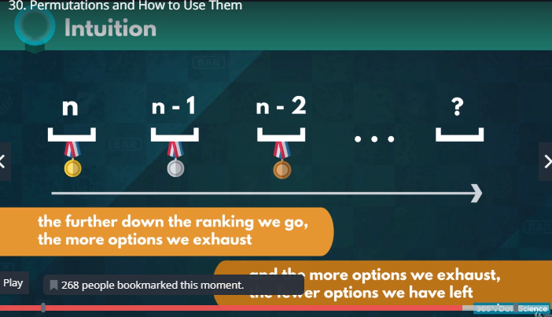

Pn = n * (n-1) * (n-2) * ……………………. * 1 = n! (factorial)

**Factorials:**

**n! 🡪** the product of the natural numbers from 1 to n

n! = 1x2x3x4x5x……………….n

3! = 1x2x3

**Odd characteristics:**

* Negative numbers don’t have a factorial
* 0! = 1

**Important Properties:**

* n! = (n-1)! x n
* (n+1)! = n! x (n+1)
* 6! = 5! x 6
* 7! = 6! x 7
* Could be expanded further to express (n+k)! and (n-k)!
* (n+k)! = n! x (n+1) x (n+2) x ……………….. x ……… (n+k)
* (n-k)! = n!/(n-k+1) x (n-k+2) ………………. Xn
* 7! = 5! x 6 x 7
* 3! = 5! / (4 x 5)

**Two Factorials**

**n>k 🡪 n!/k! = (k+1) x (k+2)x…………… x n**

**n = 7, k = 4**

7!/4! = (1x2x3x4x5x6x7)/(1x2x3x4) = (5x6x7)

**Solving Variations with repetition**

**Variations:** The total number of ways we can pick and arrange some elements of a given set.

Combination lock (2 letter code) with options A, B, C

The total number of variations =3*3 = 9

nVp = np

n – the total number of elements, we have available

p – the number of positions we need to fill

The number of variations with repetition when picking

p - many elements out of n elements, is equal to n to the power of p

Nine different variations of 2-letter passcodes consisting of A, B or C only

What if we could use any of the 26 letters?

**Variations without Repetition**

There are 5 runner in a race Tom, Eric, David, Kevin and Josh.

Who starts?

Who anchors?

Who runs in between?

1st Post can be fill by 5 options then 2nd can be fill by 4, 3rd can be fill be 3, 4th can be fill by 2, for last only one option available.

= 5*4*3*2 = 120

nVp = (n!)/(n-p)!

the number of variations without repetition when arranging p elements out of a total of n

5V4 = 5!/((5-4)! = 5! = 120

**Solving Combinations**

The number of different ways we can pick certain elements of a set.

Example: Pick 3 people to represent your company out of 10 employees.

10V3 = 720 🡪 You would be counting every group of 3 people several times, Picking Alex, Sarah and Dave

Variations don’t take into account double counting elements.

**All the different permutations of a single combination are different variations.**

Alex, Sarah and Dave – the order in which we pick them is not relevant

Any of the 6 permutations we showed is a different variation, but not a different Combination.

Pn = n! = 3! = 6

We are going to have 6 variations for ANY combination

Six times fewer combinations than variations

10V3 = 10*9*8 = 720

10C3 = 720/6 = 120

**P3 = 6 🡪 Permutations**

**10C3 = 120 🡪 Combinations**

**10V3 = 720 🡪 Variations**

**Formula:**

What’s the number of combinations for choosing p-many elements out of a sample space of n elements?

The number of combinations equals the number of variations, over the number of permutations

**C = V / P**

**nCp = nVp/Pp = (n!)/(p!(n-p)!)**

**n = 10, p = 3**

**10C3 = 10! / (3!7!) = 8x9x10/1x2x3 = 720/6 = 120**

**Technology Conference example 2**

* **Pick 4 people to represent your company**

10C4 = 10!/(4!6!) = 10x9x8x7/1x2x3x4 = 5040/24 = 210

**Symmetry of Combinations**

* Picking more elements CAN lead to having FEWER combinations

**Picnic:** you have 6 options but you can only contain 4 options if you take bigger basket even then you can only pick 5 options and if you take even more big basket then you can pick all of 6 fruits.

Picking 4 fruits out of 6, is the same as choosing 2 fruits that will be left out

6C2 = 6!/(2!4!)

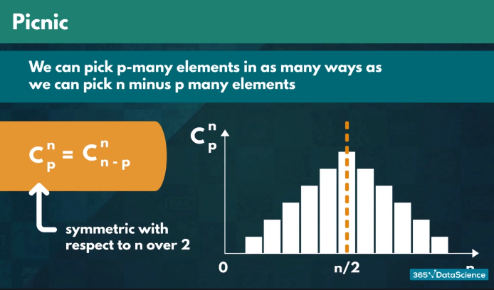

**Technology Conference Example**

* Select 3 of our 10 employees to represent the company

10C3 = 120

* What if instead, of choosing 3. We had to pick 7 people to go to the conference?

10C7 = 10!/(7!3!) = 8x9x10/1x2x3 = 720/6 = 120

* Thus, we would also have 120 different ways of picking the 7 employees
* Picking 7 out of 10 employees to take to the conference is the same as choosing 3 out of 10 to leave behind
* We prove this symmetry mathematically
* Reinforce your understanding

**Solving Combinations with Separate Sample Spaces**

A combinations can be a mixture of different smaller individual events.

**Example:**

**Lunch Menu**: Sandwich, Drink, Side

How long will it take for you to try out every possible item in the menu?

Sandwich (3 Types) + Side (2 Types) + Drink (2 Types)

Thinking about the different parts of the menu as separate positions

=3*2*2 = 12

Online Marketing:

You need to try out several versions of an online and before you decide which one is the best

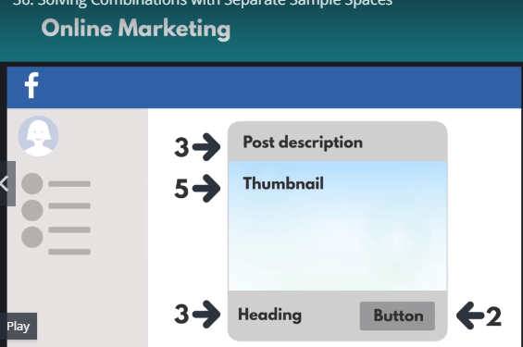

= 3x5x3x2 = 90 different adds

Heading x Thumnail x Post description x button

Determine the appropriate amount of time it would take for such a task to be completed.

Remove several of the options to tremendously decrease the workload

Calculating the total number of combinations is by multiplying the number of options available for each individual event (a*b*c)

**Combinatorics in Real Life**

**Lottery Ticket**

* Pick 5 numbers between 1 and 69
* “Powerball” number between 1 and 26

**Independent Events:** The likelihood of two independent events occurring simultaneously equals the product of their individual probabilities.

1. Guessing the Powerball number
2. Getting the correct 5 numbers

**Powerball number (only 1 favorable outcome):** P(“Powerball”) = 1/26

**Picking 5 numbers from 69:**

Orders does not matter with lottery numbers

We cannot have the same value twice

Above two indicates Combinations without repetition

nCp = n!/(p!(n-p)!

69C5 = 69!/(5!(69-5)! = 69!/5!64! > 11000000

P(5 numbers) < 1 / 11000000

**Grand Prize:**

* You also have to correctly guess the “Powerball” number
* Guessing all the numbers becomes 26 times less likely

**Winning: Two pieces of information needed**

* Number of favorable outcomes (Number of tickets we buy)
* Number of all possible outcomes (30 000 000)

**P(lottery) ~ 0.000000003**

**Summary: Two events (Permutations, Variations, Combinations)**

* Guessing the Powerball number
* Getting the correct 5 numbers

**Recap of Combinatorist**

**Arrange a set of objects (the order is crucial)**

|  |  |
| --- | --- |
| **Permutations** | **Variations** |
| Difference from variations:  You always arrange the entire set of elements in the sample space  4 Runners, 4 Positions 🡪 Permutations | Pick and arrange  6 Runners, 4 Positions, 4 Spots (Variations)  And select who runs which lags  6 Runners, 4 Spot (Combinations) |

Types of Variations and Combinations (with Repetitions and without Repetitions)

**No Repetition:** Clear relationship between P, V and C

C = V/P

We count all the permutations of a given set of numbers as a single combination, but as separate variations.

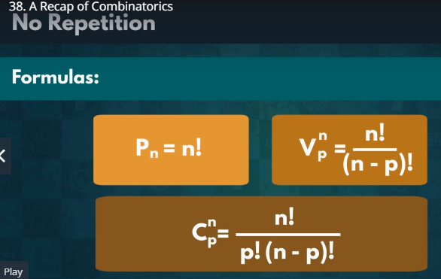

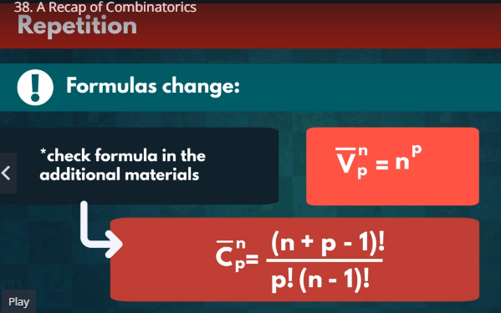

**Symmetry**

Combinations are symmetric

**nCp = nCn-p**

Choose the elements to be omitted

**Practical Example**

**Dominos Pizza**

1. One Person Combo Pack (1 Medium Pizza + 1 small drink + 1 dessert 🡪 $15.99)
2. Family Pack (2 medium pizzas, 1 small drink + 1 large drink, 2 dessert 🡪 $25.99)
3. Double Delight (2 medium pizzas, 2 large drinks, 2 desserts 🡪 $27.99)
4. 26 types of pizzas, 4 types of drink, 7 types of desserts

Initially Amy said I am not hungry

1. One Person Combo Pack (1 Medium Pizza + 1 small drink + 1 dessert) – distinct sample spaces = 26x4x7 = 728

Now I am hungry

1. Family Deal (2 medium pizzas, 1 small drink + 1 large drink, 2 dessert 🡪 $25.99) 🡪

**325x16x28=145,600 A lot of variety**

* 1. Pizza selection 26 from 2 (Combinations without repetition) 🡪 26C2 = 325
  2. Drinks (Variations with repetition) 🡪 4V2 = 16
  3. Desserts (Combinations with repetitions)🡪 7C_2 (7Cbar2) = (n+p-1)!/(p!(n-1)! = 8!/(2!6!) = 7x8/(1x2) = 28

1. Double Delight (2 medium pizzas, 2 large drinks, 2 desserts 🡪 $27.99)

**325x12x28 = 109,200 possible orders**

* 1. Pizza selection 26 from 2 (Combinations without repetition) 🡪 26C2 = 325
  2. Desserts (Combinations with repetitions)🡪 7C_2 (7Cbar2) = (n+p-1)!/(p!(n-1)! = 8!/(2!6!) = 7x8/(1x2) = 28
  3. Drink (We can get different drinks since we can share) – it is important how you order the two beverages – Variations without repetitions 🡪 4V2 = 12

We will opt Family deal (145,600) > Double Delight (109,200) options.

**Probability – Bayesian Inference**

Describing events and how they interact with each other.

Event 🡪 set of outcomes (favorable outcomes)

Even 2,4,6

Sets 🡪 Values of a set don’t always have to be numerical

Event 🡪 being a member of European Union

France & Germany – Yes, USA and Japan – No

Denoted as

Set 🡪 UPPER CASE

Elements 🡪 lower-case

Sets 🡪

Any set can be either empty or have values in it (the empty set = null set) crossed 0

Non-empty sets.

1. Finite
2. Infinite

**Part of a set:**  “x ϵ A” (element ϵ set)

x is an element of the set

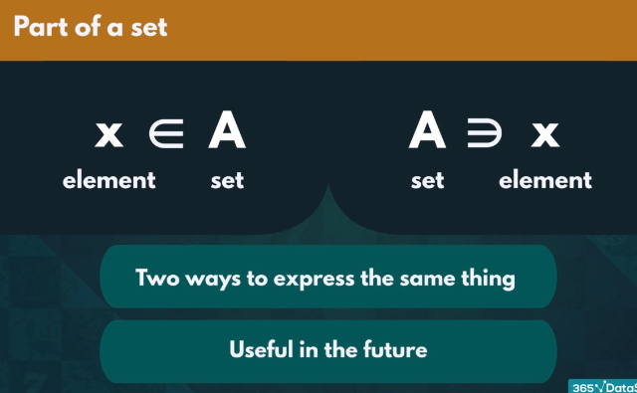

What if we want to show that an element is NOT contained in a set?

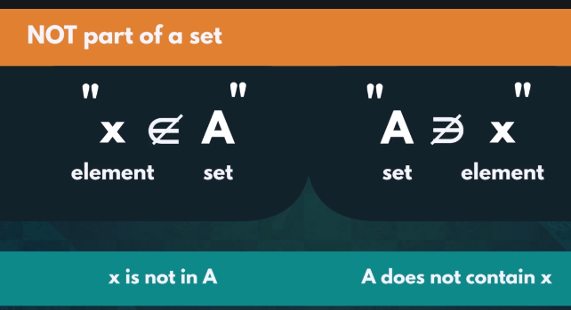

Ɐ - for all / any

“Ɐ x ϵ A” 🡪 for all x in A

**:** - such that

Incredibly useful when we want to make statements about a specific group of elements within a set

**Ɐ x ϵ A : x is even**

for all x in A, such that, x is even

**Subset:** A set that is fully contained in another set.

Every element of A is also an element of B 🡪 **A is a subset of B**

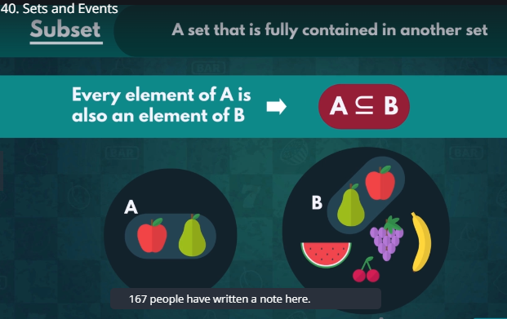



**Up Ahead**

* We are ready to explore how different events interact
* We will show you how to visualize relationships between two or more events

**Two Events:**

* **Never Touch:** 
  + The two events can never happen simultaneously
  + Event A occurring guarantees that event B is not occurring and vice versa (heart and diamond in a deck)
* **Intersecting:**
  + The two events can occur at the same time
  + Event A is a diamond and event B is a Queen. Intersection is Queen of Diamonds

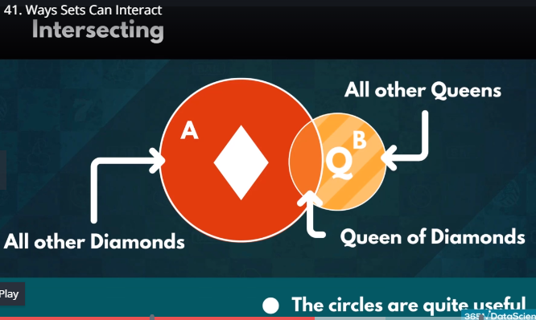

* **Completed Overlapped:** 
  + One event can only ever occur if the other one does as well
  + Event A Red Card and Event B is Diamonds
  + Means if event A does not occur, then neither does event B
  + It is possible to get a Red Card that isn’t a Diamond (B not occurring >=<> A not occurring)

**Conclusion:**

* If an outcome is NOT part of a set, it cannot be part of any of its SUBSETS.
* An outcome NOT being part of SOME subset, does not EXCLUDE it from the entirely of the greater set

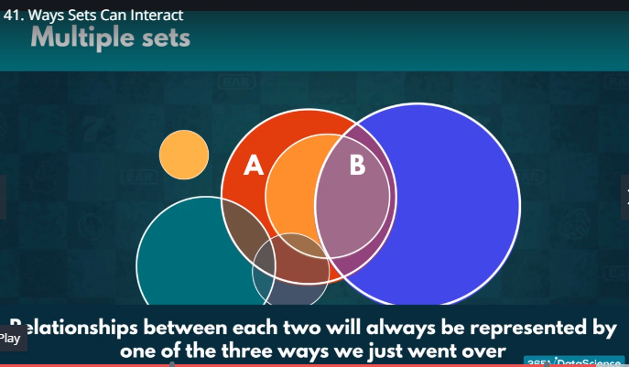

**Intersections of sets:**

The area where both events occurs.

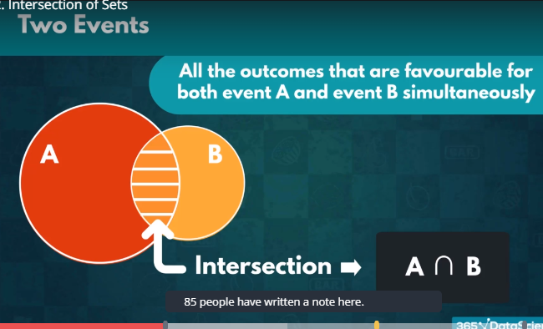

**Different Intersections:**

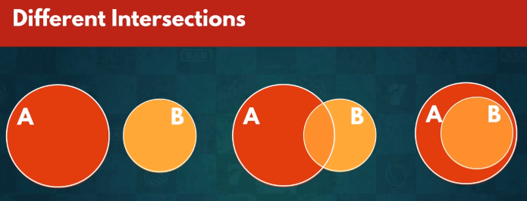

**Examples of Intersections:**

* The intersect of Heart and Diamonds is the empty set.
* There are no outcomes which satisfy both events simultaneously
* All Diamonds and All Queen: the only one that satisfies being a queen and being a diamond at the same time
* All Red Cards and All Diamonds: Intersection of the two would simply be “ALL DIAMONDS” (A ꓵ B) = B

**UNION of SETS**

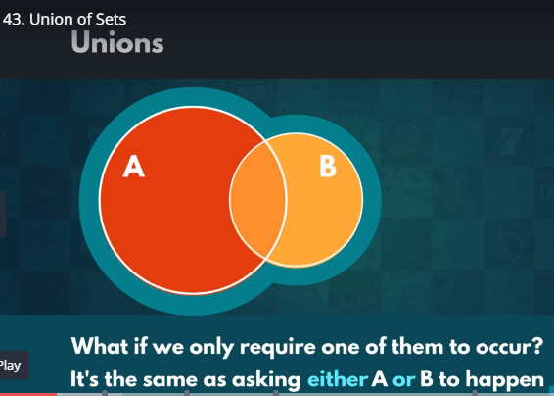

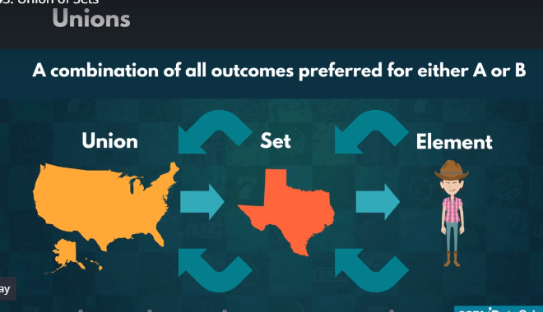

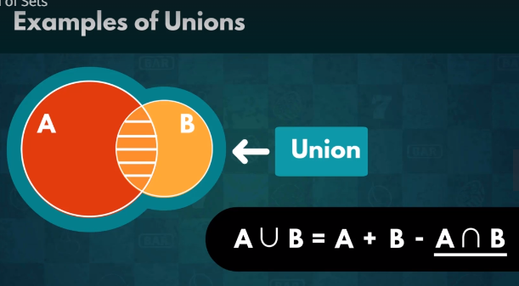

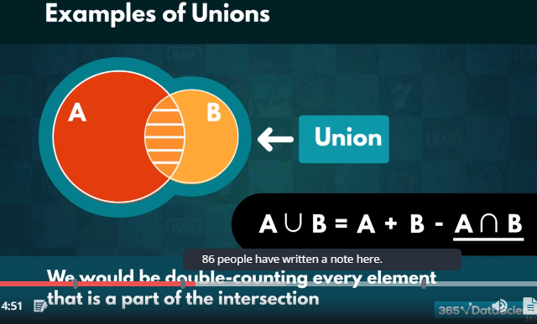

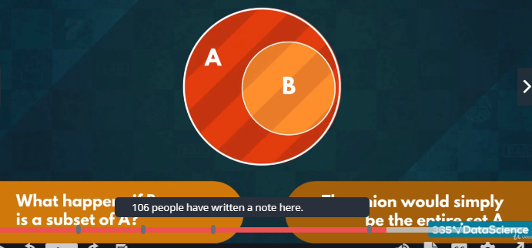

All Californians and Americans = All the people from the USA

A ꓵ B = B (All Californians), A U B = A

The union of all Californians and Americans equals the entire population of the USA.

**Mutually Exclusive Sets**

Sets, which are not allowed to have any overlapping elements.

Two not touching circles A and B 🡨 Their circles never intersect

**So far:** Mutually exclusive sets have the empty set as their intersection

**Now:** If the intersection of any number of sets is the empty set, then they must be mutually exclusive

What about their union?

If A and B are mutually exclusive 🡪 A U B = A+B

**Complements:**

**Complement Set:** All values that are part of the sample space, but not part of the set

Sets have complements too

* Complements are ALWAYS mutually exclusive
* NOT all mutually exclusive sets are complements

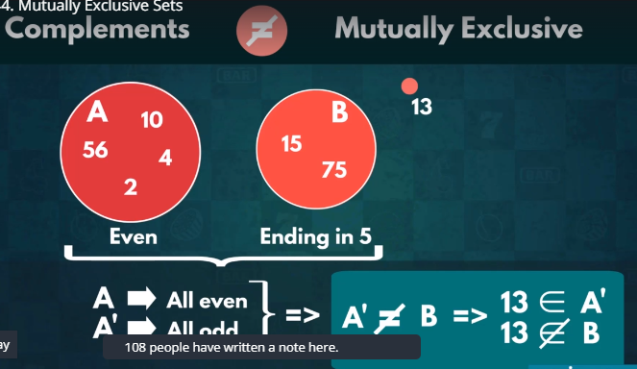

**INDEPENDENT AND DEPENDENT EVENTS**

**Independent Events:** The theoretical probability remains unaffected by other events

You always have a 50% chance of getting tails.

**Dependent Events:** Probability of dependent events vary as conditions changes.

**Queen of Spades Example1:**

P(Queen of Spade) = 1 / 52

Imagine we know that the card we drew was a spade

P(Queen of Spade) increases New sample space contains the 13 cards => P(Queen of Spade) = 1/13

Imagine we know our card is a queen

P(Queen of Spade) increases new sample space contains the 4 cards 🡪 P(Queen of Spade) = 1 / 4

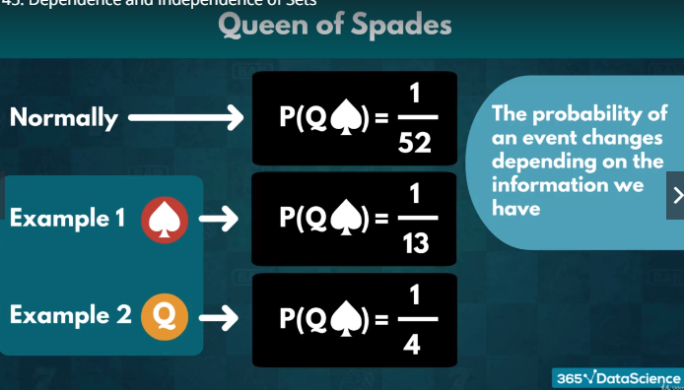

**Notation:**

Two events: A and B

The probability of getting A, if we are given that B has occurred P(A|B) “A given B”

A🡪 Queen of Spade, B 🡪 Spade, C🡪 Queen

P(A|B) 🡪 the probability of drawing the Queen of Spades if we know the card is a spade = 1/13

P(A|C) 🡪 the probability of drawing the Queen of Spades, assuming we drew a queen = ¼

**Conditional Probability: P(A|C) 🡪 We use it to distinguish dependent from independent events**

**Conditional Probabilities:** The likelihood of an event occurring, assuming a different one has already happened.

How to compute and interpret such probability P(A|B)

Two coin flips

A 🡪 Head

B 🡪 Head

P(A|B) = 0.5 = P(A) 🡪 Independent

P(A ꓵ B) = P(A) x P(B)

**Queen of Spades:**

A🡪 Queen of Spade, B🡪 Spade, C 🡪 Queen

P(A) =1/52, P(A|B) = 1/13

Because two events are dependent

Similarly P(A|C) <> P(A)

A and C are also dependent

**P(A|B) = P(A**ꓵ**B)/P(B)**

If P(B) = 0 🡪 Event B would never occur, A|B 🡪 Not interpretable

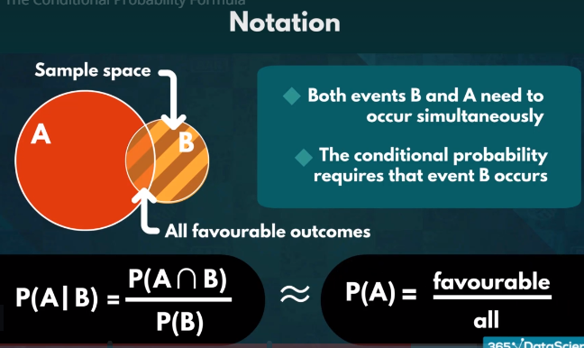

Importance:

* The order in which we write the elements is crucial
* P(A|B) is not the same as P(B|A)

**Conditional Probability in Real Life**

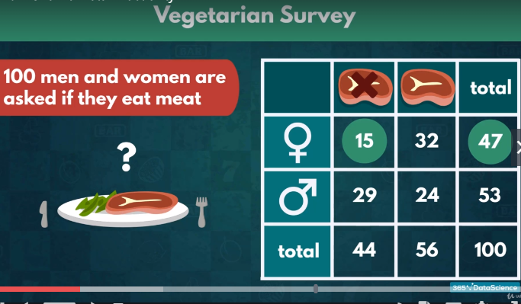

P(A|B) is not the same as P(B|A)

P(A|B) = 15/47 the likelihood of a woman being vegetarian

P(B|A) = 15/44 the likelihood of a vegetarian being woman

P(A|B) < P(B|A)

**Law of Total Probability**

A = B1 U B2 U ……………….. U Bn

P(A) = P(A|B1) x P(B1) + P(A|B2)xP(B2)

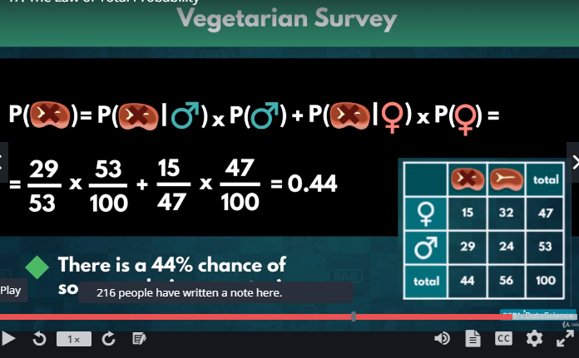

**Additive Law**

The probability of the union of two sets is equal to the sum of the individual probabilities of each event, minus the probability of their intersection.

P(AUB) = P(A) + P(B) – P(A ꓵ B)

P(Tableau) = 38%, P(SQL) = 45%, P(Tableau U SQL) = 66%, P(Tableau ꓵ SQL) = ?

P(AUB) = P(A) + P(B) –

P(A ꓵ B) = P(A) + P(B) – P(AUB) = .38+.45-.66 = .17 = 17%

A likelihood of .17 for somebody in the office to be able to work on both Tableau and SQL.

**Multiplication Rule**

P(A|B) x P(B) = P(A ꓵ B)

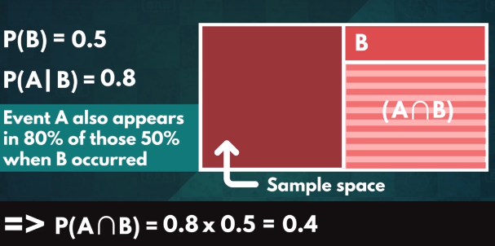

**Bayes’ Rule = Bayes’ Theorem = Bayes’ Law**

P(A|B) = P(B|A) x P(A)/P(B) 🡨 Conditional Probability Formula

P(A ꓵ B) = P(B|A) x P(A) 🡨 Multiplication Rule

It allows us to find a relationship between the different conditional probabilities of two events.

**Medical Research:**

* Trying to find a causal relationship between symptoms
* Helps us make more reasonable arguments about which one causes the other

We can also apply Bayes’ Theorem in Business

Good Academics vs Experience

P(Exp) = 45%, P(Grades) = 60%, P(Grades|Exp) = 50%

P(Exp|Grades) = .5x.45/.6 = .375

P(Exp|Grades) = .375 < P(Grades|Exp) = 0.5

Candidates who had internships are more likely to also have a high GPA

**Bayes’ Rule in Independent Events**

P(code working) = 0.3, P(Sun) 0.4

P(Sun|code working) = 0.4

P(code|Sun) = P(Sun|Code) x P(Code)/P(Sun) = 0.4x0.3/0.4 = 0.3

The chances of your algorithm performing as intended neither increase, nor decrease based on the weather.

**Practical Example**

**Hamilton College**

* Bayes’ Law
* Diversifying its student population
* > 25%

Common data set for 2017-2018 year: A free public dataset of summarized statistics



**Probability Distribution**

The possible values a variable can take and how frequently they occur.

Y 🡪 The actual outcome of an event

y 🡪 one of the possible outcome

P(Y=y) or p(y)

Y 🡪 The number of red marbles we draw out of a bag

y 🡪 specific number (3 or 5)

P(Y=5)

p(5) 🡪 The probability function

Probabilities measures the likelihood of an outcome

Recorded the frequency for each unique value and divide it by the total number of elements.

* Possible when finite number of possible outcomes
* Not possible when infinite number of possibilities

**Two characteristics:** mean (average value ), variance – σ2 (how spread out the data is)

Population (all the data) vs Sample data (just a part of it)

Standard Deviation 🡪 square root of variance – σ for population, s for sample

* Same units as the mean
* We can directly interpret it

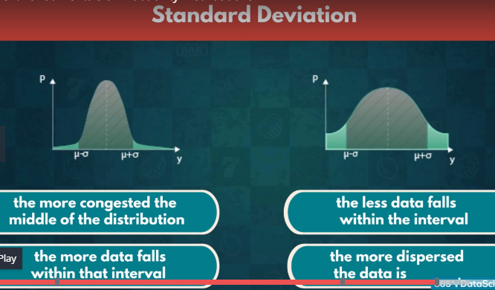

**Mean and Variance**: - a constant relationship between mean and variance

σ2 = E((Y-Meu)2) = E(Y2) – Meu2

**Types of Probability Distributions**

Rolling a die and picking a card

Finite number of outcomes 🡪 Discrete distributions

Recording time and distance have infinitely many outcomes 🡪 Continuous distributions

In this lecture: we will examine the characteristics of the most common distributions

* Important Aspects
* When distributions are used

**Notation:**

X ~ N (Meu, σ2)

**Discrete Distributions:-**

Picking a card from a deck, or flip a coin

All outcomes are equally likely 🡪 Equiprobable

Uniform Distributions

Events with two possible outcomes 🡪 True or false fall into Bernoulli Distribution

An event with two outcomes can be transformed into a Bernoulli event

Elect a captain from 7 Native students and 3 International.

Carrying out a similar experiment several times in a row

* Binomial distribution
* Poisson Distribution 🡪 Test out how unusual an event frequency is for a given interval
  + In a basketball match 35 points per game
  + 12 points in the first quarter of his next game P(12)=?

**Continuous Distribution:** the probability distribution would be a curve

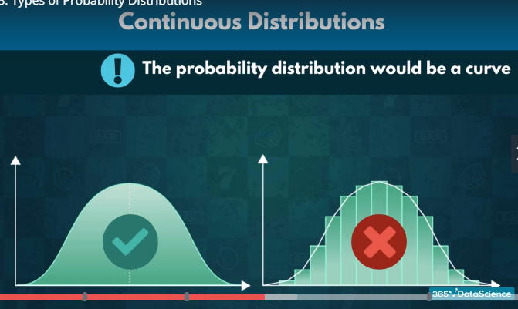

* **Normal Distributions**🡪 often observed in nature
* The weight of adult polar bear is around 500 Kg. and ranges from 350 to 700.
* Limited data
* **Student’s -T distributions** (accommodates extreme values significantly better)

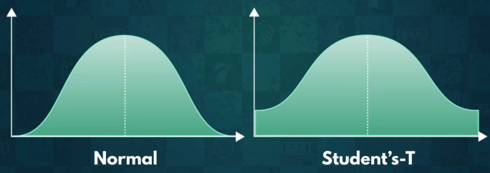

* **Chi-Squared distribution**:- does not often mirror real life events
  + Used in Hypothesis testing
  + Goodness of fit

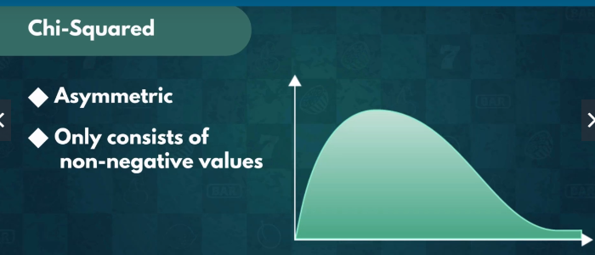

* **Exponential Distribution:** Events that are rapidly changing early on
  + Online news article (Breaking news)
* **Logistic Distributions:**
  + Useful in forecast analysis
  + Used for determining a cut-off point for a successful outcome
  + In Dota 2:
  + How much of an in-game advantage is necessary to predict victory
  + Our predictions would never reach true certainty

**Discrete Distributions**

Finite many distinct outcomes

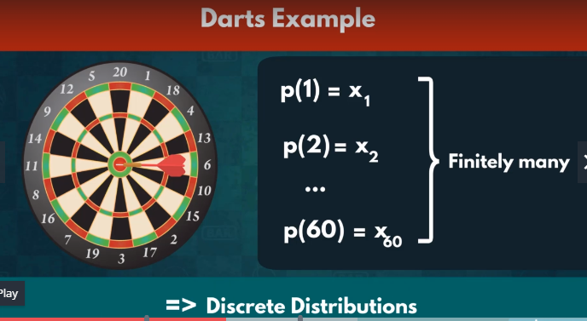

**Peculiarity:**

P(Y<=y) = P[Y<(y+1)]

P(Spade <= 3) = P(Spade < 4)

**Uniform Distribution**

**U(a,b) 🡪 X ~ U (3,7)**

All outcomes have equal probability

P(1) = P(2) = P(3) = P(4) = P(5) = P(6)

**Everyday Situation:**

**X🡪 Choosing a specific chocolate**

**X ~ U(3)**

**Expected Value 🡪** provides us no relevant information

E(getting 3 in a dice) = 3.5

No predictive power

**Mean and Value**: Mean = 3.5, Variance = 105/36

Main Takeaway🡪 X ~ U(a,b)

* Each outcome is equally likely
* Both the mean and variance are uninterpretable
* No predictive power

**Bernoulli Distributions**

**Bern (p) 🡪 X ~ Bern (p)**

**Events with:**

* **1 Trial**
* **2 Possible Outcomes**

**p is known or past data indicating some experimental probability**

**Assigning 0 and 1**

**Assigning which outcome is 0, and which outcome is 1**

**Head 🡪 0, Tail 🡪 1, E(X) = p**

**Conventionally: p> 1-p**

E(X) = 1.p + 0.(1-p) = p

The likelihood of the favored event

1 Trial 🡪 We expect that outcome to occur

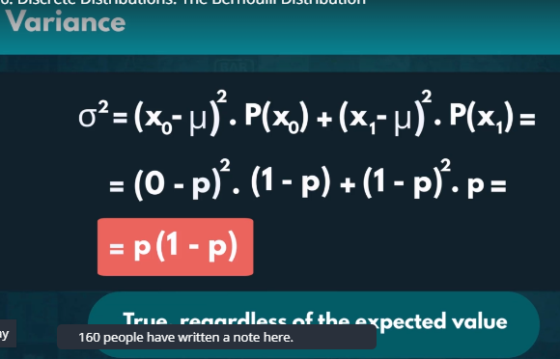

**Binomial Distribution**

* A sequence of identical Bernoulli events

**Notation:** B(n, p), X ~ B(10, 0.6) => Bern(p) = B(1,p)

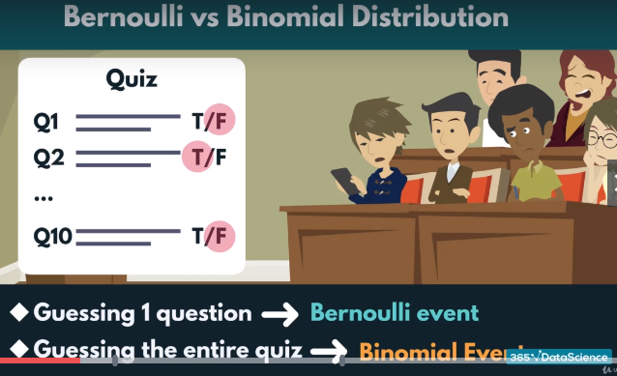

E(Bernoulli Event) 🡪 which outcomes we expect for a single trial

E(Binomial Event) 🡪 The number of times we expect to get a specific outcome

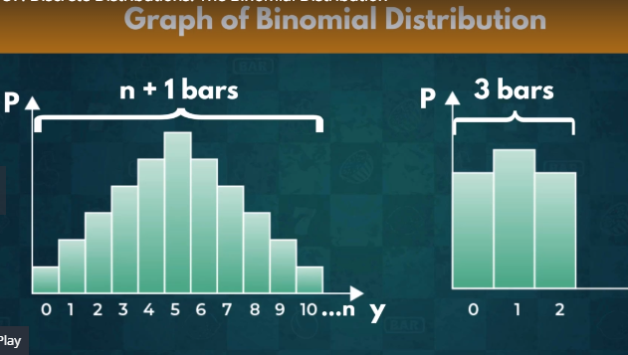

**The Probability Function:** The likelihood of getting a given outcome a precise number of times p(y)

P(desired outcome) = p

P(alternative outcome) = 1-p

They could exist more than one way to reach our desired outcome

The number of ways in which 4 out of 6 trials can be successful = Picking 4 elements out of a sample Space of 6 = 6C4

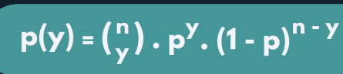

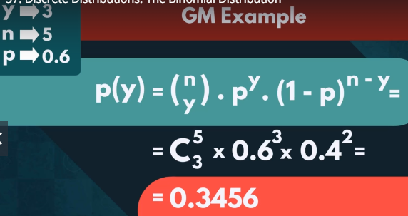

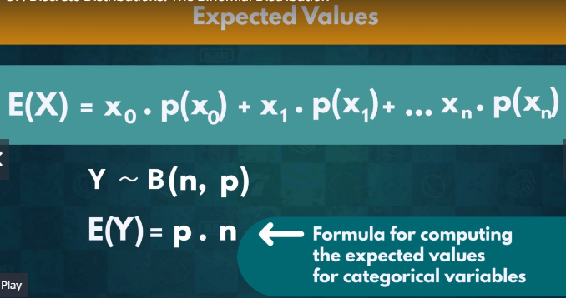

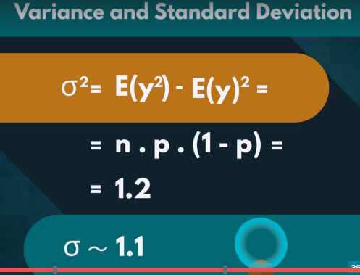

**Poisson Distribution**

The frequency with which an event occurs

Firefly Example- 3 times in 10 sec

P0(λ) 🡪 Y ~ P0(4)

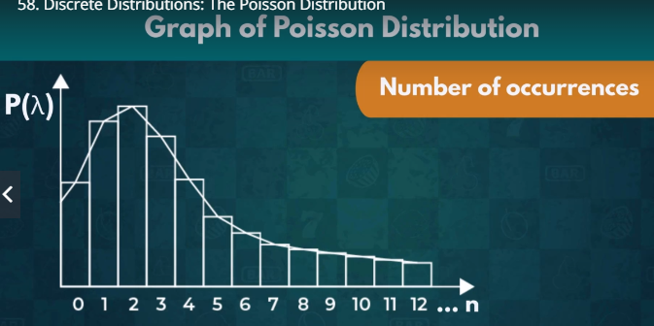

Q&A Example:

λ = 4, interval = one day, y = 7

Probability function for P0(4)

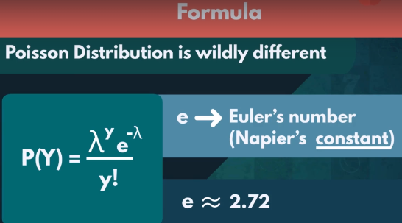

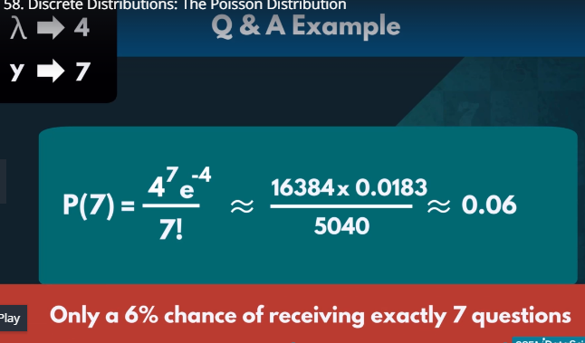

**Expected Value**

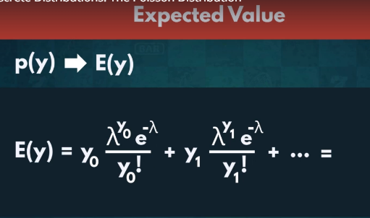

Mean = Variance = Lambda

**Continuous Distributions**

* Sample space is infinite
* We cannot record the frequency of each distinct value
* Represents them with graphs

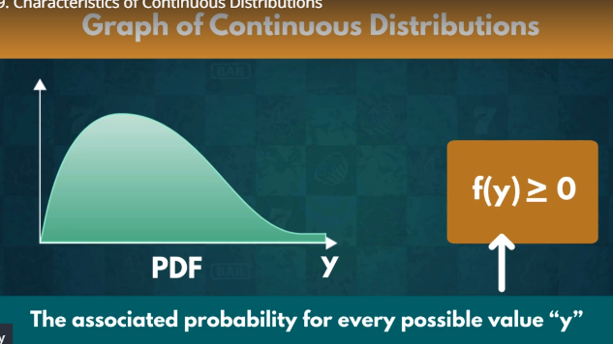

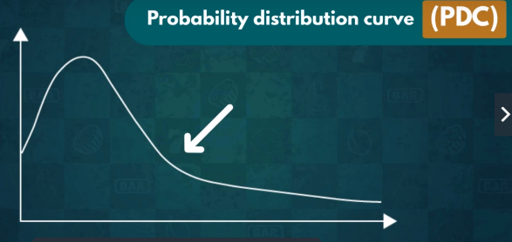

Discrete vs Continuous

P(y) = favorable/sample space = 1/infinite

The likelihood of each individual one would be extremely small

The greater the denominator becomes, the close the fraction is to 0.

The Probability for any individual value equal to 0

P(X) = 0

P(X>X) = P(x>=X)

P(x<6min) = P(X<= 6 min)

**PDF for Discrete Function**

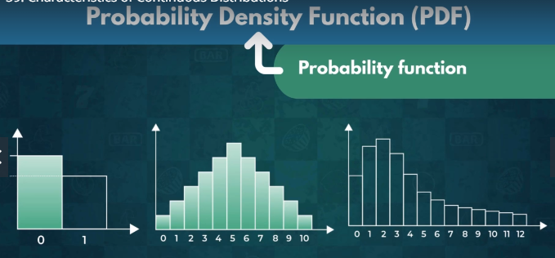

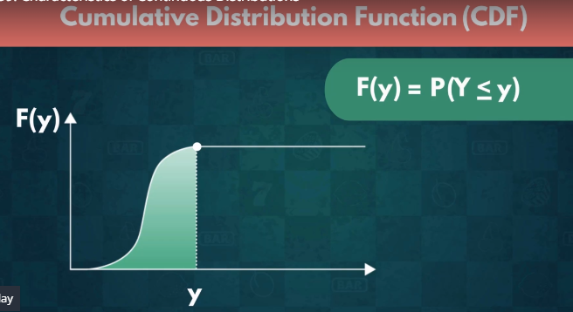

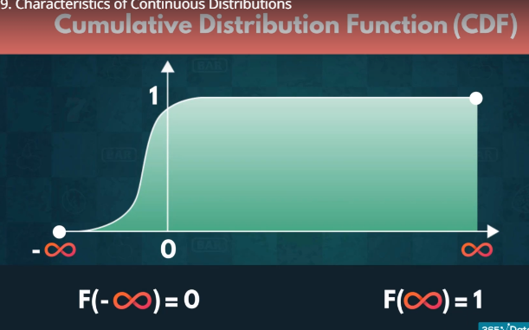

Discrete CDFs

* Far less frequently used
* We can add up the PDF Values

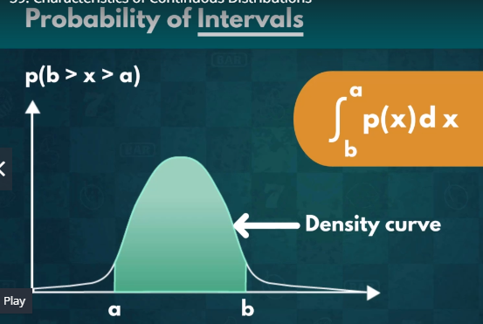

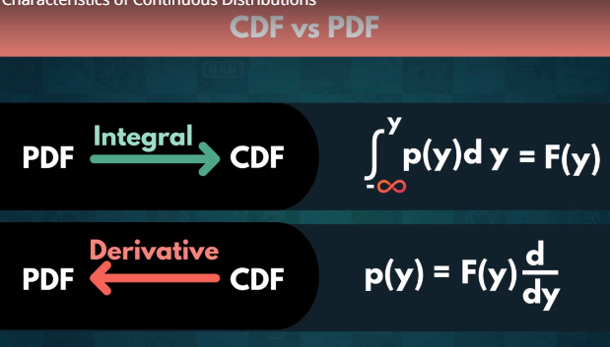

**PDF Graph**

**Only Given PDF**

**Compute: E(y) = ?, Var(y) = ?**

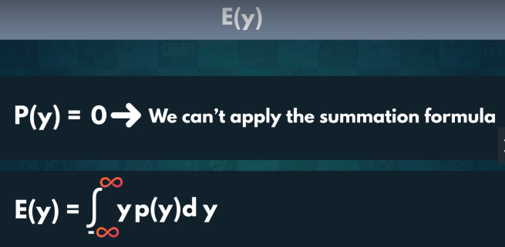

**Var(y) = E(y2) – E(y)2**

**Normal Distribution**

**N(Meu, σ2)**

**X ~ N(Meu, σ2)**

The Lions weights range from 150 Kg to 250 Kg. If the weights of the lions measures outside the interval called outliers.

Distinct Characteristics:

* Bell Shape and symmetric

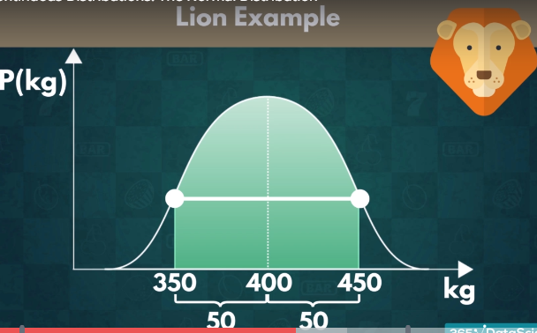

Expected Value

E(X) = Meu

Var(X) = E(X2) – E(X)2

**68, 95, 99.7 Law:** Any normally distribution event 68% of the all outcome fall within 1 SD away from the mean. 95% fall within 2 and 99.7% fall within 3.

* Outliers are extremely rare
* Elegant Statistics

**Standardizing**

What is standardizing?

Why do we use “Standardizing?

Transformation

A way in which we can alter every element of a distribution to get a new distribution.

If we add a number in the function it will shift to the right

If we substract a number in the function it will shift to the left

If we multipy a number in the function it will shrink from y-axis

If we divide a number in the function it will expand through y-axis

**Standardizing:-** A special kind of transformation

E(X) = 0, Var(X) = 1 🡪 Standard Normal Distribution

68, 95, 99.7% Rule 🡪 CDF Table (Z-score table)

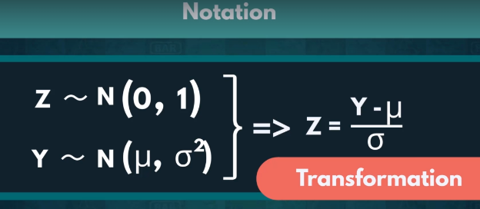

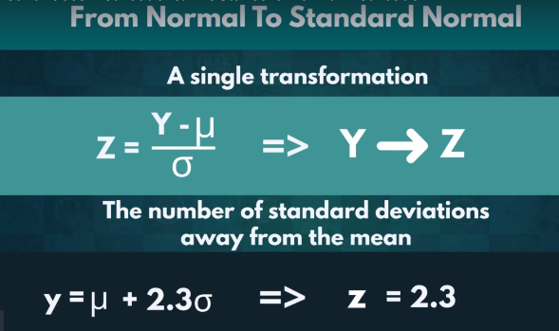

**Drawbacks:**

* Useful when we have a Normal Distribution
* Not always the case
* It requires a lot of data
* Risk of outliers drastically affecting our analysis

**Student’s t Distribution**

t(k) 🡪 Y ~ t(3)

Small sample size approximation of a Normal Distribution

Certain characteristics + Sufficient data = Normal Distribution - True

Certain characteristics + sufficient data = Student’s T distribution -False

Average lap times for the entire season = Normal Distribution

Lap times for the first lap of the Grand Pre = Student’s T distribution

The curve of Student’s t distribution is the bell curve but have flatter tails. To accommodate the occurrence of values far away from the mean

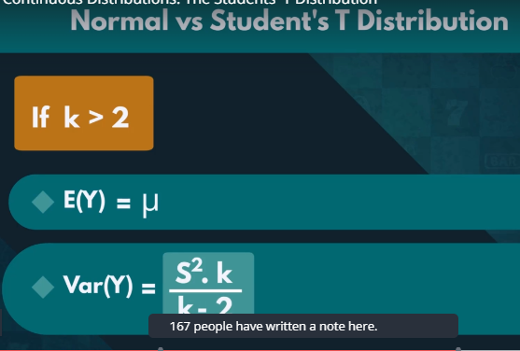

**Application**

* Frequently used when conducting statistical analysis
* Hypothesis testing with limited data
* CDF table (T-table)

**Chi-Squared Distribution**

χ2(k) 🡪 Y ~ χ2(k)

**Applications:**

* Few events in real life
* Statistical analysis
  + Hypothesis testing
  + Computing confidence intervals
* Goodness of fit

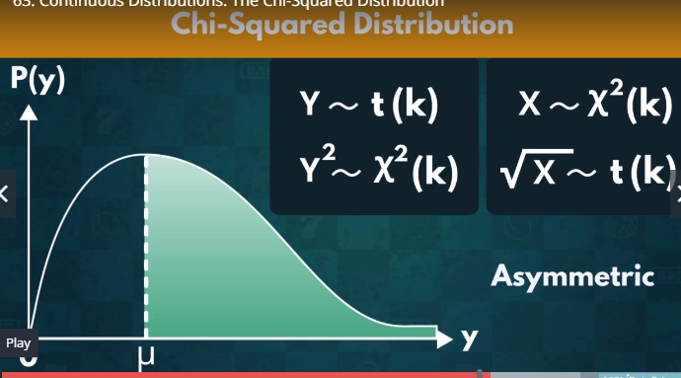

**Convenience:**

* A table of known values: N, T
* E(X) = k
* Var(X) = 2k

**Exponential Distribution**

Exp(lambda) 🡪 X ~ Exp(1/2)

* Starts off high
* Initially decreases
* Eventually plateauing

Number of view over time

* Aggregate amount of view keeps increasing
* Number of new ones dimishes
* Viewership focus shifts away
* => most likely for a random viewing to have occurred close to the video’s initial release

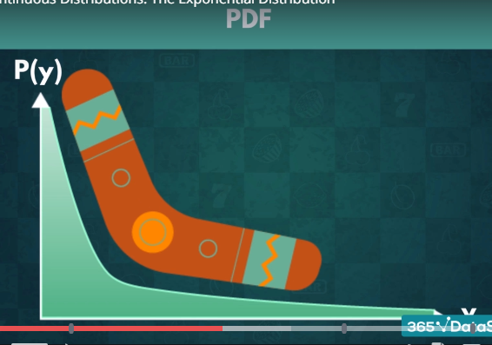

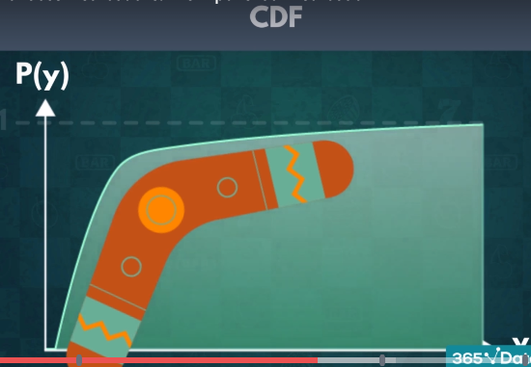

Rate Parameter (lambda)

* How fast the CDF/PDF curve reaches the point of plateauing
* How spread out the graph

E(Y) = 1/lambda

Var(Y) = 1/lambda2

**Drawbacks:**

* Unlike Normal or Chi Squared
* No table of known variables (Z-table; Chi-Squared table)
* Transform it

Transformation: One of the most famous transformation

Y~ Exp(lambda)

X = ln(Y)

* X~ N(Meu, σ2)

**Logistic Distributions**

Logistic (Meu, S) 🡪 Meu🡪 Location, S🡪 Scale Parameter

Y ~ Logistic(6,3)

**Application:**

* Forecasting: Victory or Defeat
* Expectation:-
  + Mps🡪 sending the ball from a high velocity gives shorter period for the opponent to react --> 1
* Reality:- High Velocity🡪 Low Accuracy 🡪 0

Theory:

Optimal speed 🡪 still accurate

Most of the shots we convert into points will likely have similar velocities

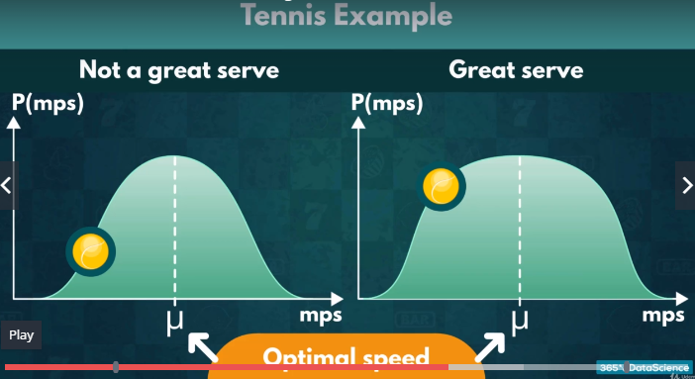

**Serena Williams:-** Fantastic serves even if the ball moves much faster or slower than it optimally should

CDF (Cumulitive Distribution Function):

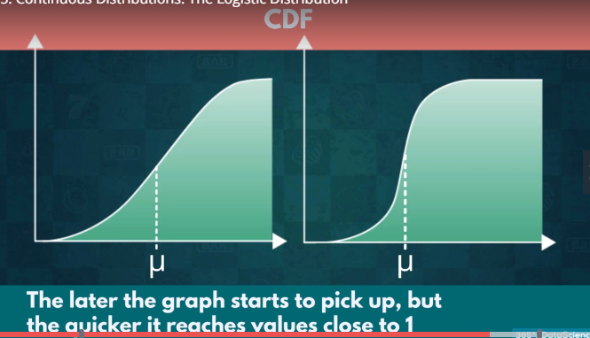

Expected Value E(Y) = Meu

Var(Y) = S2Pi2/3

**Practical Example**

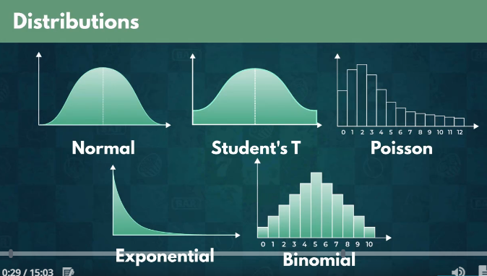

**EA Games – FIFA- 19**

* Well rounded
  + Balanced (No team or individual player should invariably be a preffered option)
* Genuinely enjoyable

Analysis:

Histogram of Overall Metrics which shows the performance of the player with bin width of 1

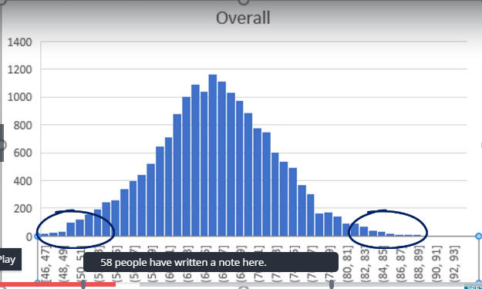

Analysis of top 30 overall metrics with bin width 1 to check whether t distribution works here. You can check t distribution is symmetric and have flater tail

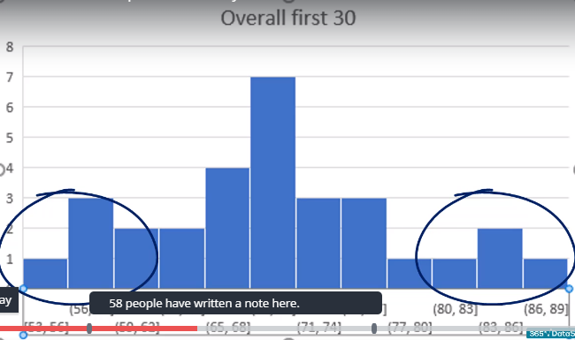

Shot Power analysis: seems two groups in the graph with different means of 21 and around 65. Reason behind this the presence of golkeeper in this game.

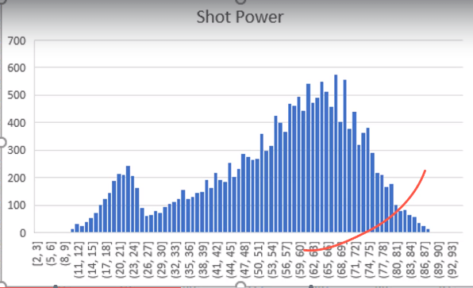

Analysis of GK Diving for Golkeeper: It also show two group in the graph. First one is for golkeeper and other one is for other.

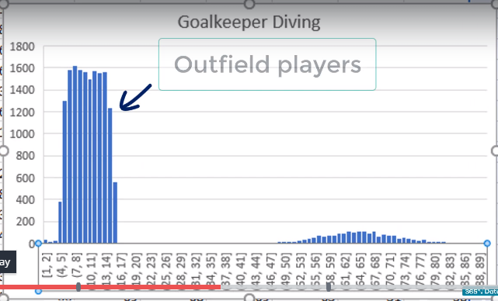

Reasons why there are more young players than old players:

1. Bad Injuries
2. Retire early
3. Go to university

These are the reason for young players.

Age analysis: It follow Poisson Distribution and you see the outliers in both side

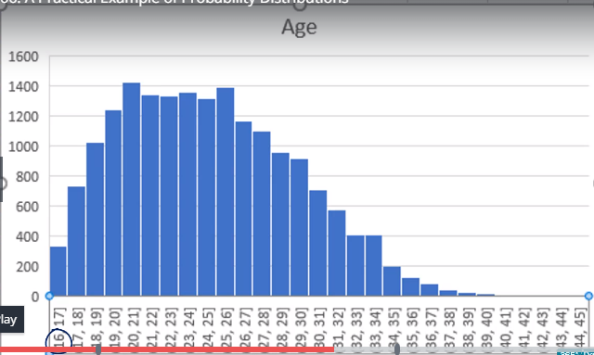

Head Project Manager Responsibilities:

1. Development of the game:
   1. Balanced
   2. Realistic
2. Supervise the realse:
   1. Social Media Marketing (Competitor Analysis): Free video previews of new games to expand customer base
3. Customer Analysis

**Daily View Excel file for Social Media Marketing Activity: PDF and the trend line with exponential function**

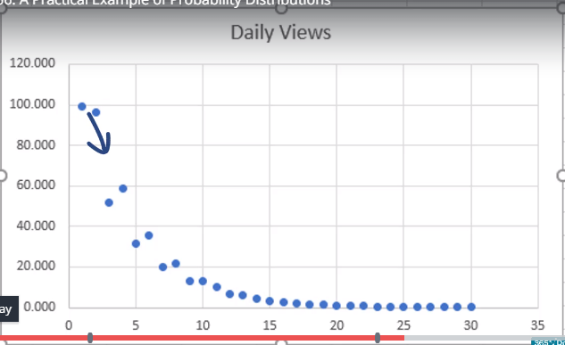

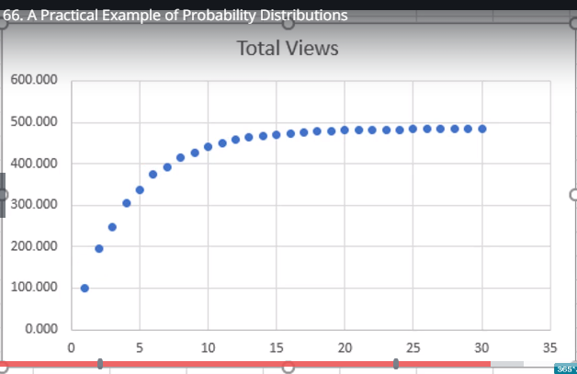

Compaign is only beneficial in the short term.

Release video during last month before launch.

We need to focus on premium member of the official fan club because members are financially strong and great interest in the game.

**Customer Membership files: 34 is the approximate age at which customers can afford higher membership fees.**

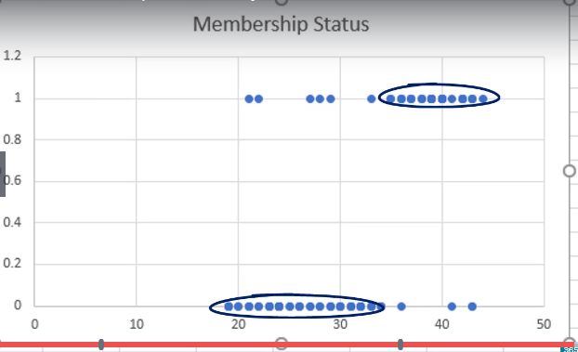

In this lecture, you

* Saw numerous examples where knowing how to deal with distributions is truly beneficial.
* Developed an understanding of the practical aspect of probability
* Discovered why knowing how the data is distributed can help us make correct business decisions

**Probabilities in Other Fields**

**Probability in Finance**

**Option Pricing:** An agreement between two parties for the price of a stock or item at a future point in time

* It allows one of the side to decide
* One of the parties at a clead disadvantage

How much we are willing to pay to receive that pact? (Highest premium)

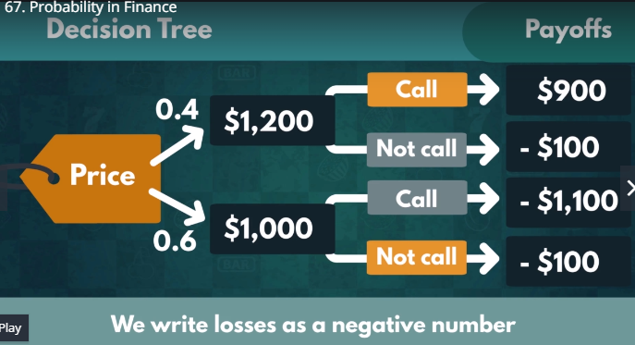

E(P) < 0 Disadvantageous (Avoid buying this option)

E(P) = 0 “Fair Deal” (You expect to make as much as you paid)

E(P)> >0, Favorable (Go through with the deal)

E(P) = 0.6*(-100) + 0.4*900 = 300

E(P) >0 Favorable 🡪 Buy this option

If the investor has same information as you: E(P) <= 0

* Unfavorable deal for you
* Fair deal (Usually)

Investor can charge a higher premium to make a fair deal

* Premium up by 300, E(P) down by 300
* Deal with 400%

Calculating E(P) if there is no premium:

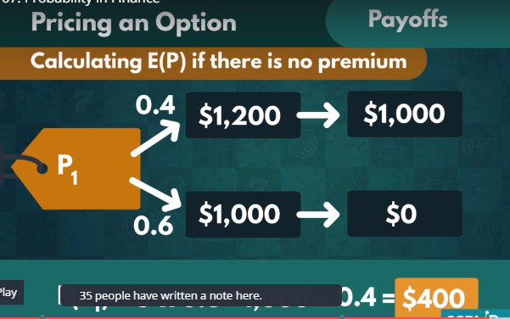

E(P1) = $400 matches highest premium estimation from before

What if the stock value only increases to 1125?

Probabilities in Finance:

Many of the assigned probabilities are ballpack figures. Values are not a 100% certain!

**Statistics**

|  |  |
| --- | --- |
| **Statistics** | **Characteristics** |
| Sample  60% of 1000 people eye color is brown | Population  65% of the people eye color is brown |

Statistics focuses predominantly on samples and incomplete data

Uncertaintly

Expected Value and prediction intervals

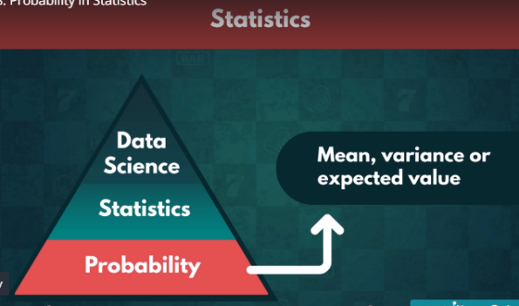

**Experimental data**

* Many useful concepts based on probability theory
* Express the likelihood of the population mean being within that interval
* Degree of certaintly – 90%, 95% or 99%

Confidence Intervals: Approximate some margins for the mean of the entire population

To calculate these Cis we must know:

* Mean, Variance and standard deviation
* A good understanding of probability is crucial

**Average meal in the north london:**

Mean = 22.5, E(X) = 22.5

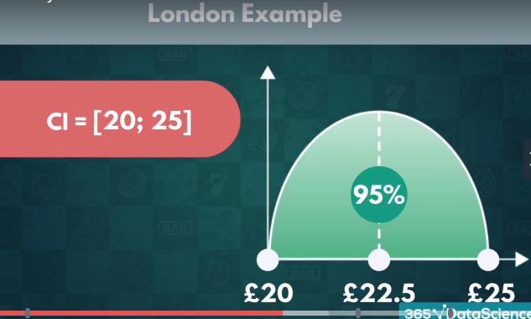

**Hypothesis Testing**

A hypothesis is an idea that can be tested.

H0 : P < 30

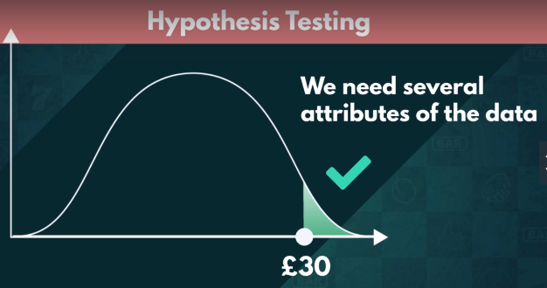

Three crucial requirement for hypothesis testing:

* Mean, Variance and type of the distribution
* We can validate similar statements to a specific degree of certainty

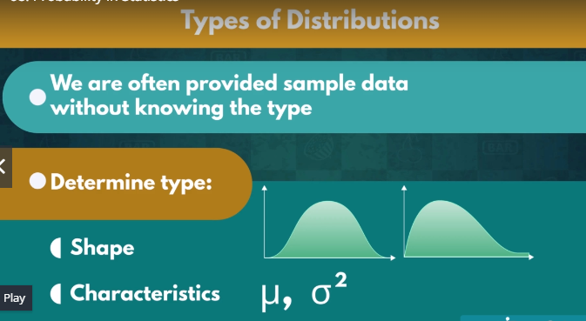

**Choosing a distribution**

* The same logic is often applied in statistics
* Any distribution predicts a value for all points within our dataset
* The distribution anticipates the actual data point

A type of anticipated average value

Knowning the type of a distribution

* **Create different models called Mathematical Modeling:** i.e. Linear or Logistic Regression (Computationally expensive, Computer Software)

**Mathematical Modeling:** An extension of statistics that data scientist deal with (Supervised Machine Learning)

**Relationship between Probability and Data Science**

**Data Science:**

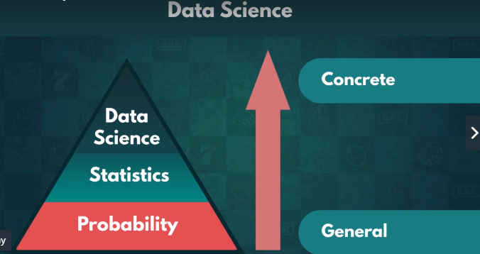

Regressions are genelly Supervised Machine Learning:

Data Analysis:

* Analyse past data
* Find insight
* Make reasonable predictions

**Mathematical Modelling:** We run artificial simulations to see how well our predictions match up to various possible future outcomes.

**Monte Carlo Simulation:** We generate artificial data to test the predictive power of our mathematical models

* Not completely random data
* Follow restrictions – P(x) = 0.4 of the data must match the outcome
* We can tweak restriction
* Many models look well when train them
* Perform poorly with new data

**Expected Values:**

**ML:** An extremely fast paced trial-and-error process

The more predictions it makes, the more precise they become

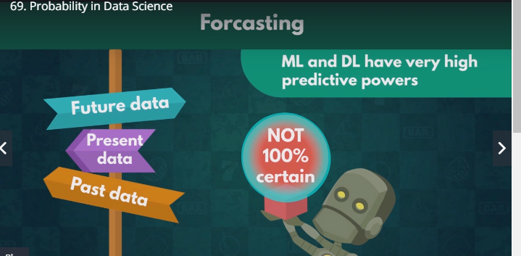

Unpredictable events can occur in real life: Earth quake, Volcanic Eruption or sudden scientific breakthrough can completely change the anticipated course of events

= > Even data scientists assign probabilities to their predictions

**Data Scientist:** An expansion of probability, statistics and programming that implements computational technology to solve advanced questions (NOT 100% certain). It is fundamental to understand Probability.